Winter Break:

**Maintenance Reminders**

Note to supervisors: Please post a hard copy of this reminder on the bulletin board in the coffee room

# HVAC Schedule

I hope everyone is looking forward to the winter break. Most of the campus buildings will be closed, and to minimize energy consumption, the air conditioning and heating system will be operating on reduced run times or completely turned off in certain areas. Specific instruction for all campus buildings is given below.

## Dorms

In open dorms and sorority and fraternity housing, no changes to run times will be made.

In closed dorms, the HVAC systems will be turned off on December 17, 2018 and turned on again on January 4, 2019.

## Academic Buildings

Campbell Science Hall will operate normally.

Hampton Library will operate during office hours, from 8 AM to 5 PM, on Mondays through Fridays.

Jones Student Center will operate from 8 AM to 6 PM daily, except weekends.

Moore Gymnasium will operate from 7 AM to 7 PM daily.

The HVAC in all other academic buildings will be turned off on December 15, 2021 and then turned on again on January 2, 2022.

## Administrative Buildings

HVAC systems in administrative buildings (Edwards and Stevenson Halls) will be turned off from December 15, 2021 through December 26, 2021 and from December 30, 2021 through January 2, 2022. On operating days between December 17, 2021 and January 2, 2022, the HVAC systems will run between 7:00 AM and 5:00 PM.

Manual overrides are available in the administrative buildings. Press the green presence button on any thermostat on a floor to activate the override for that floor. The override turns on the system for three hours at a time.

# Reminders

Please inform students and staff that before they leave for the winter break, they must remember to complete the following tasks.

## Break Areas

* Empty refrigerators of any perishable food and drinks, especially cheese and fruits.
* Clear ice trays.
* Wipe down the inside of the refrigerator with a clean wet cloth.
* Put a box of opened baking soda in the middle shelf of the refrigerator.

## General Tasks

1. Set thermostats to 65 degrees.
2. Close all doors and windows securely.
3. Remove all living plants from the area.
4. Open all air vents.
5. Turn off all lights.

## Office Spaces and Other Areas

* Unplug chargers and space heaters. Space heaters can be especially dangerous due to the reduced HVAC run times.
* Turn off appliances such as stereos, TVs, and digital signs.
* Remove any cardboard boxes or flammable products from the area.

If you have any questions, please contact: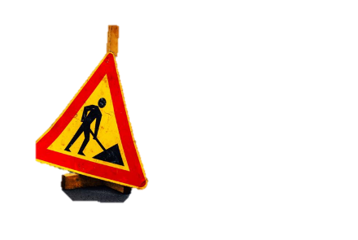

Maintenance Department

Tel: 888-555-5555

Website: http://maintenance.ourcollege.edu

Email: maintenance@ourcollege.edu